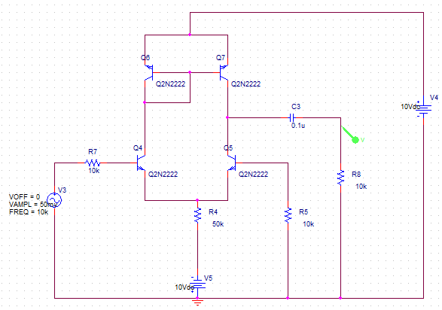**CIRCUIT DIAGRAM**

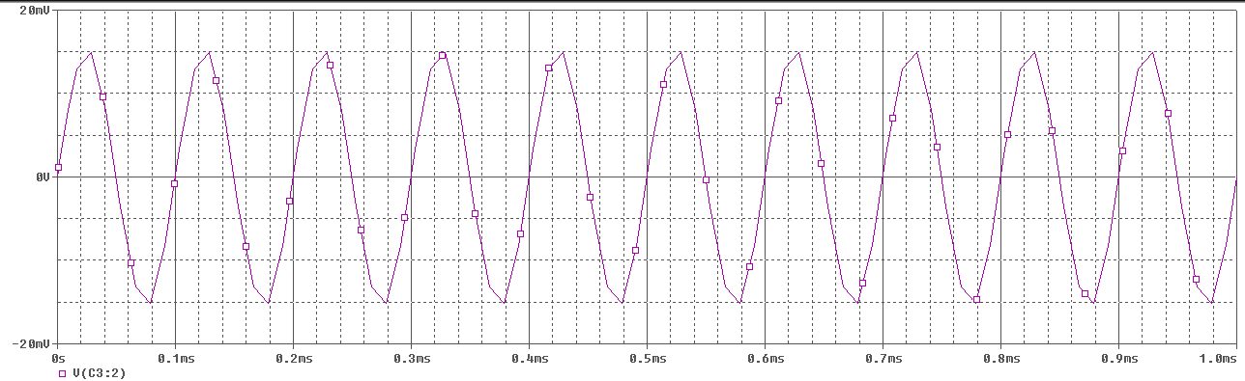**OUTPUT WAVEFORM**

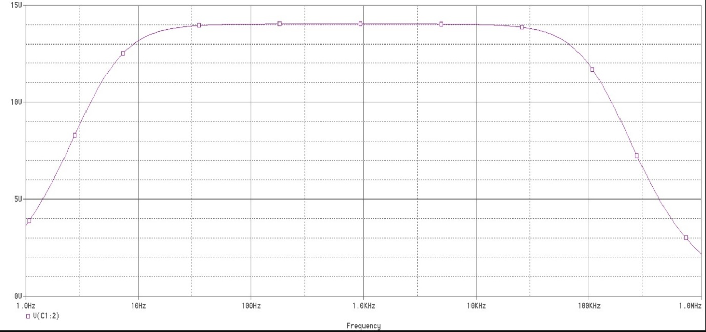**FREQUENCY RESPONSE**